Lab 6 – Building a Responsive Movie Genre Browsing Screen
1. Objective
In this lab, students will design and implement a responsive movie browsing screen that adapts to different screen sizes (small phones, large phones, tablets, and web).
The lab reinforces the key ideas from Module 6 – Responsive UI & Adaptive Layouts, including:
- Using MediaQuery to read screen dimensions
- Using LayoutBuilder to adapt to available space
- Using Wrap, Expanded, and ListView/GridView to build responsive layouts
- Building a real-world Genre Filtering Screen similar to the one shown in Figures 6.1–6.9 of Mastering Flutter 2025.
At the end, students will have a fully functional responsive screen that runs correctly in:
- DartPad (Flutter)
- Android Studio
- VS Code
2. Requirements
This lab is structured into three sub-tasks inside a single project:
- Lab 6.1 – Responsive Hero & Heading Section
- Lab 6.2 – Search, Genre Chips & Sort Bar
- Lab 6.3 – Responsive Movie List & Tablet Layout
You may complete these progressively in the same main.dart file.
2.1 Functional Requirements
Your responsive movie browsing screen must:
- Display a title heading, e.g. “Find a Movie”.
- Include a search bar that allows users to type a movie title or keyword.
- Display a set of genre chips (Action, Drama, Comedy, etc.) that can be toggled on/off.
- Include a sort dropdown with at least the following options:
  - A–Z
  - Z–A
  - Year
  - Rating
- Show a list of movie cards for matching movies, including:
  - Poster image (use a simple network placeholder image)
  - Title
  - Year
- Filter the visible list of movies based on:
  - Search text (case-insensitive match in title)
  - Selected genres (if any genre is selected, only show movies that have at least one of those genres)
- Adapt the layout responsively:
  - On small screens: movie cards stacked in a single column list
  - On wider screens (e.g. >= 800 px): movie cards arranged in two columns (e.g. using GridView.count)
2.2 Technical Requirements
- Use Flutter and Dart only (no third-party packages).
- The entire demo must run from a single file (e.g. main.dart), so it can be pasted into DartPad → New Flutter.
- Use MediaQuery and/or LayoutBuilder to implement breakpoints, not hard-coded “device names”.
- Use SafeArea to avoid notches / camera cutout issues.
- Use Wrap for genre chips so they automatically wrap to the next line.
- Code must compile and run without errors in:
  - DartPad (Flutter mode)
  - Android Studio
  - VS Code
2.3 Optional Enhancements (Bonus)
You may optionally:
- Add a small “badge” with the number of selected genres.
- Display movie rating as stars or numeric text.
- Add a “Clear filters” button.
- Provide different poster sizes for tablet vs phone using LayoutBuilder.
These are not required for passing the lab but can improve your score.

3. Guided Steps
Step 1 – Project Setup
- Create a new Flutter project (e.g. flutter create lab6_responsive_ui)
or open DartPad → New Flutter.
- Replace the default main.dart content with the Full Demo Code at the end of this lab (or start from an empty MaterialApp and follow the steps).
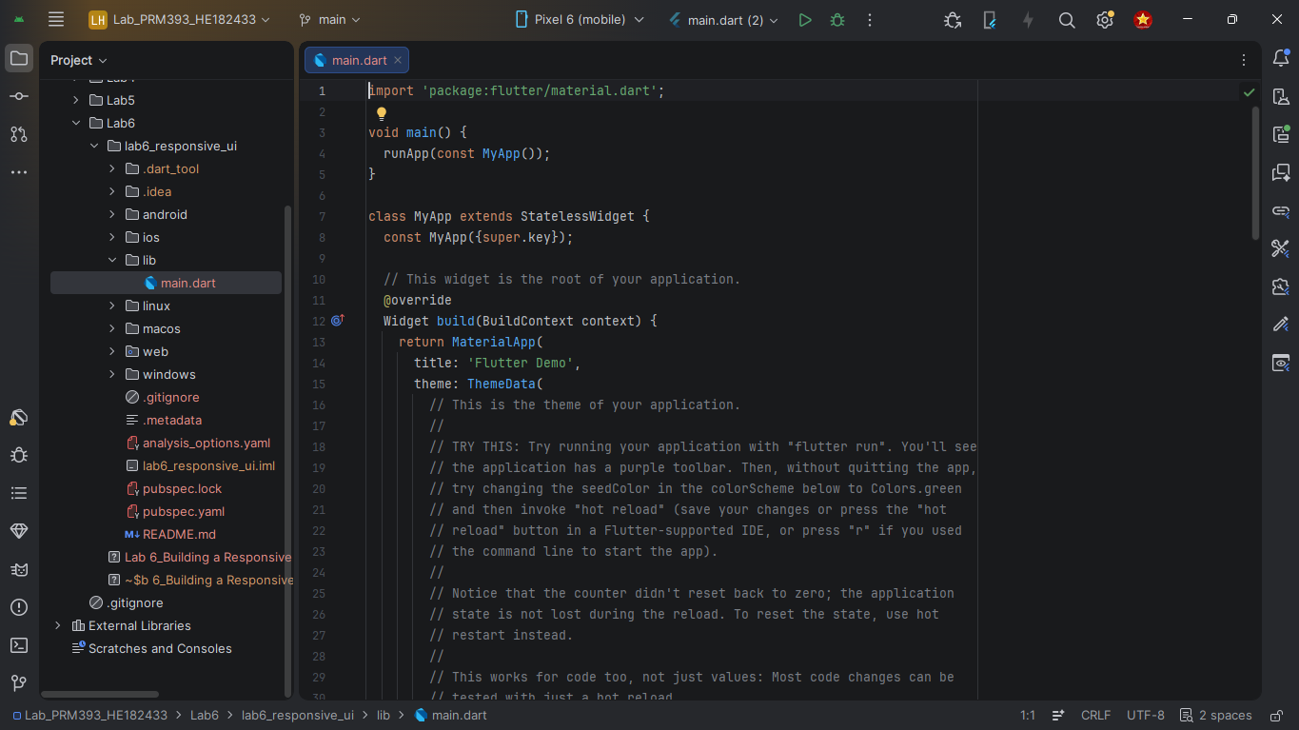
Step 2 – Define the Movie Model & Sample Data
- Create a simple Movie class with fields:
  - title (String)
  - year (int)
  - genres (List<String>)
  - posterUrl (String)
  - rating (double)
- Define a constant list of sample movies (3–6 items) in a variable like allMovies. This allows you to build UI first without backend/API.
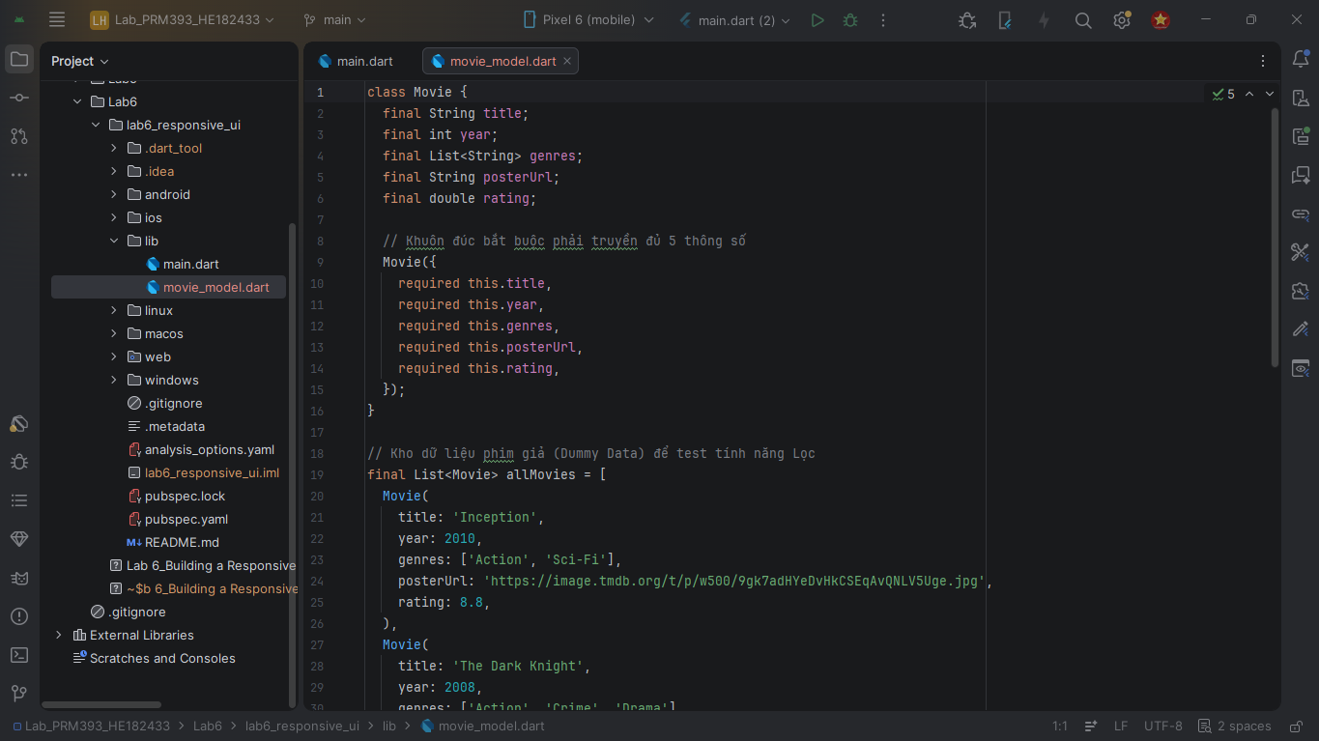
Step 3 – Build the Base Scaffold
- Create a ResponsiveMovieApp widget that returns a MaterialApp.
- Set home to a GenreScreen (stateful widget).
- Inside GenreScreen, wrap content in SafeArea and Padding.
The basic layout should look like:
- Title: “Find a Movie”
- Then vertical column for search bar, genres, sort, and movie list.
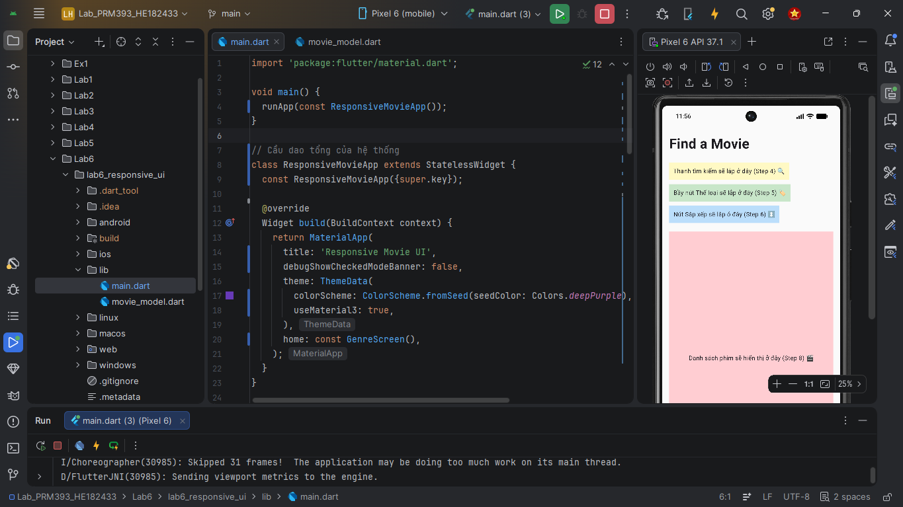
Step 4 – Implement a Responsive Search Bar
- Add a TextField wrapped in a rounded container to simulate a search bar.
- Add a state variable String searchQuery = '';.
- In the onChanged callback of the TextField, update searchQuery using setState.
- Use searchQuery later in your filtering logic to filter movies by title.
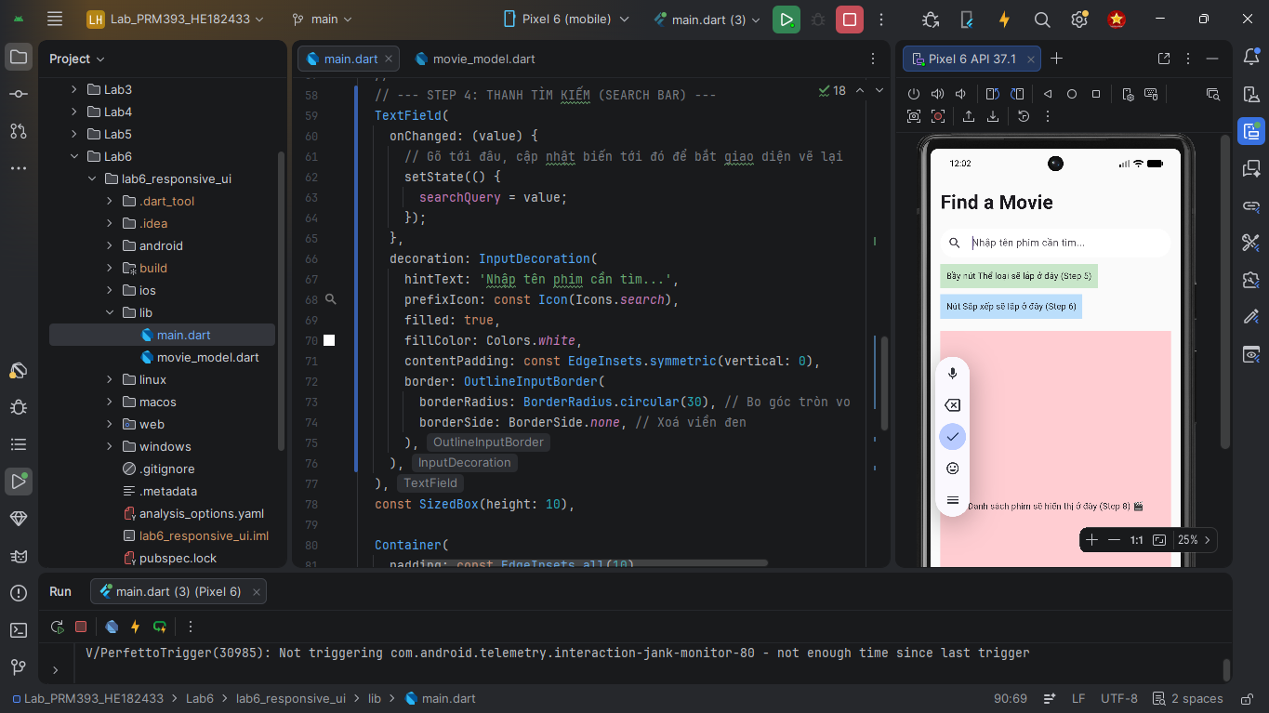
Step 5 – Implement Genre Chips Using Wrap
- Declare a List<String> genres = [...] with some default genres.
- Add a Set<String> selectedGenres = {}; or List<String> to track selected items.
- Use a Wrap widget to display all genres as tappable chips.
- When a chip is tapped:
  - If it was selected, remove it from selectedGenres.
  - Otherwise, add it.
The Wrap widget will automatically wrap chips to the next line, making it responsive.
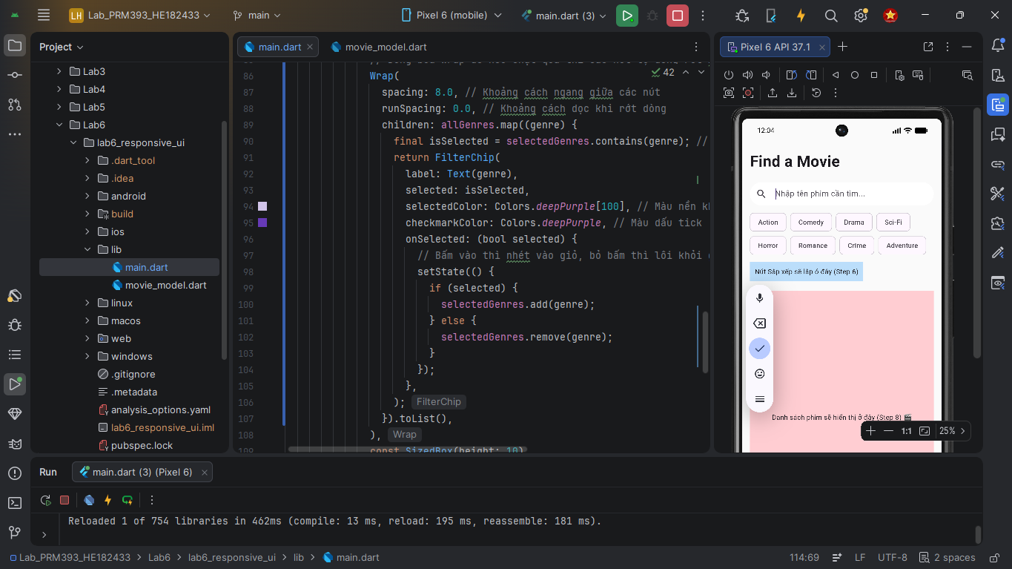
Step 6 – Implement Sort Dropdown
- Create an enum or string values to represent the sort options (A–Z, Z–A, Year, Rating).
- Add a DropdownButton<String> bound to a state variable (e.g. selectedSort = "A-Z").
- In the onChanged callback, update the sort variable and call setState.
- Later, apply sorting to the filtered list before displaying it.
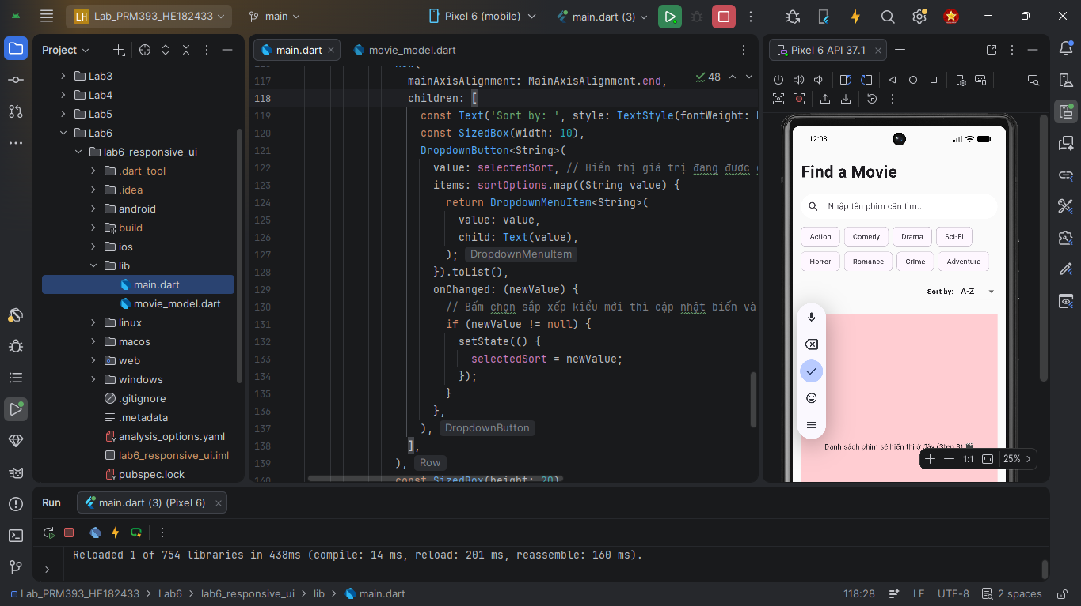
Step 7 – Filter and Sort the Movie List
- Build a computed list (e.g. List<Movie> visibleMovies) inside build() based on:
  - Search query
  - Selected genres
- Then sort visibleMovies according to selectedSort.
- You can use .where() and .toLowerCase() for filtering, and .sort() for ordering.
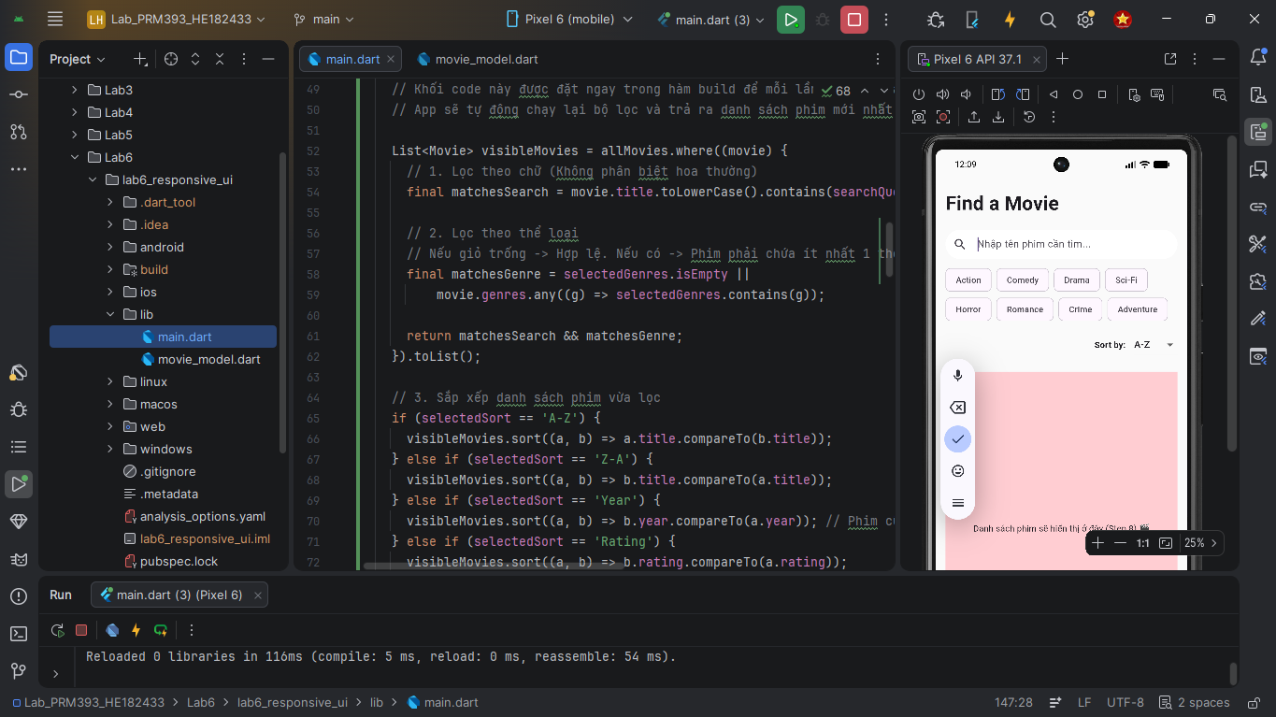
Step 8 – Build a Responsive Movie List (ListView + LayoutBuilder)
- Wrap the movie list area in an Expanded widget inside the main Column.
- Use a LayoutBuilder to decide layout based on constraints.maxWidth:
  - If maxWidth < 800: use a ListView.builder with a single column.
  - Else: use a GridView.count with crossAxisCount: 2.
- Each movie item should show:
  - Poster image (Image.network)
  - Title
  - Year
Use LayoutBuilder again inside a movie card to adjust poster size based on item width.
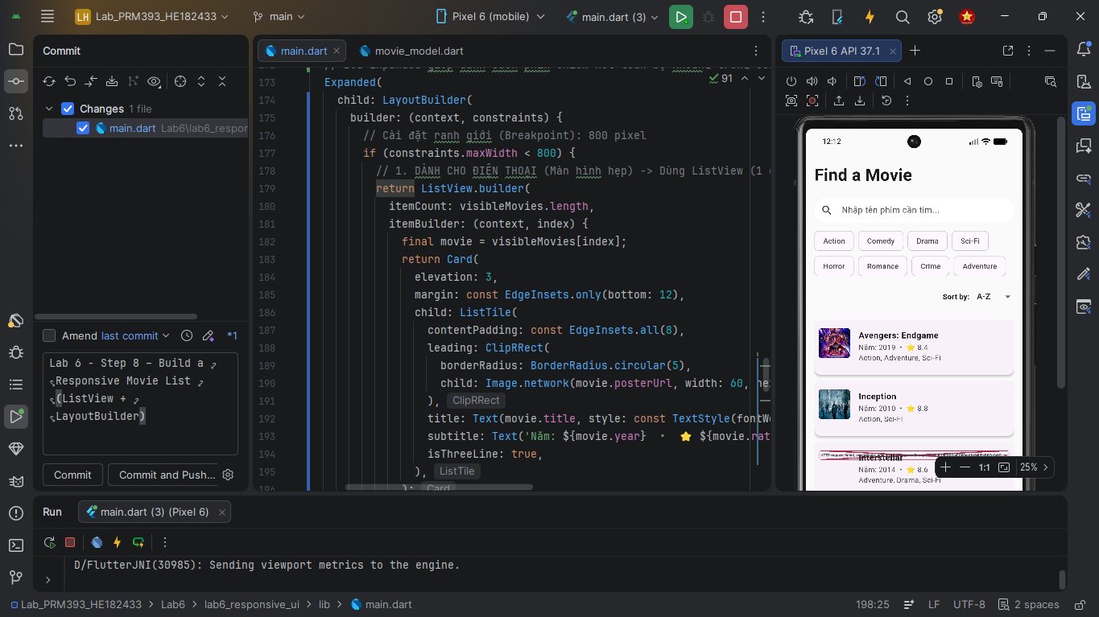
Step 9 – Test on Different Devices / Viewports
- In DartPad:
  - Resize the preview pane
  - Switch orientation
- In Android Studio / VS Code:
  - Run on a small phone emulator
  - Run on a larger phone
  - Run on a tablet emulator / Chrome Web
Confirm that:
- Chips wrap properly
- Movie list layout changes at the breakpoint
- Nothing overflows or gets clipped
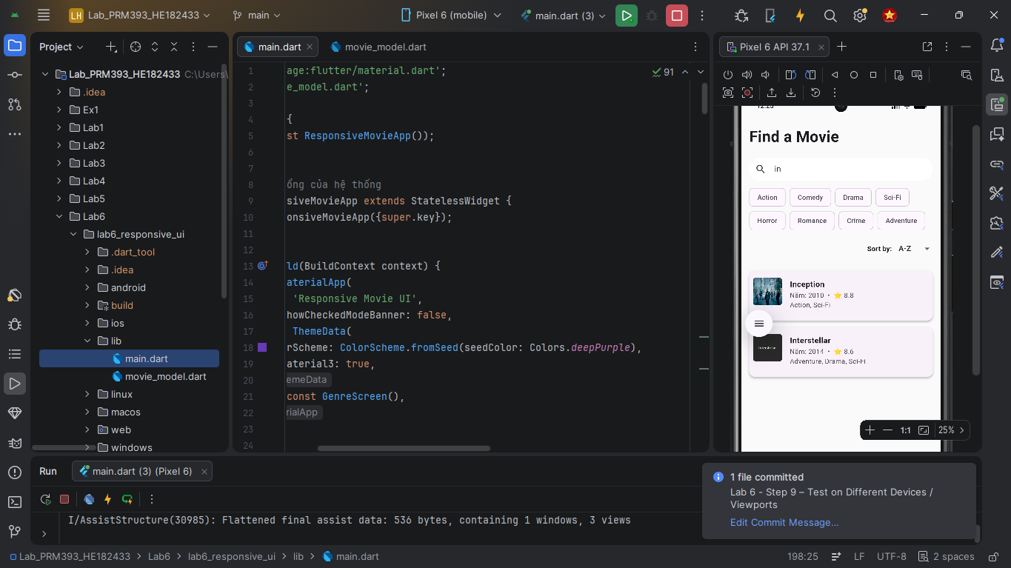

4. Expected Result
When you finish the lab, your app should:
- Show a title “Find a Movie”.
- Display a search bar that filters the list by movie title (case-insensitive).
- Display a genre chip section at the top; selecting chips filters the list by genre.
- Provide a sort dropdown that affects the order of displayed movies.
- Adapt the layout based on screen width:
  - Phones: single-column vertical list of movie cards.
  - Tablets / Wide web windows (≥ 800 px): two-column movie layout.
- Match the look & feel of the Genre Screen from Figures 6.1–6.9 in Mastering Flutter 2025 (not pixel-perfect, but functionally similar).
5. Submission
Deliverable:
- A zipped Flutter project or a DartPad Flutter share link containing the completed responsive screen.
Evaluation Criteria:
- Responsive Layout Logic (30%)
Correct use of MediaQuery / LayoutBuilder and breakpoints for phone vs tablet.
- UI Composition & Design (30%)
Clear layout with readable text, chip design, and movie cards.
- Filtering & Sorting Functionality (25%)
Search, genre selection, and sort options work as expected.
- Code Quality & Clarity (15%)
Clean, readable code with meaningful names and comments.

